Comparing Northern Territory elections, 1974-2016:
Independent success in a strong two-party system

Will Sanders, Australian National University

Abstract
Electoral success of independents and minor parties is often interpreted as indicating a weakening of two-party systems of political competition. This paper, on all 13 elections for the Northern Territory Legislative Assembly since 1974, observes that independents have enjoyed far more success than minor parties. It argues that independent success has reflected a continuing strong two-party system, not a weakening one.
Six of 10 successful independents in NTLA elections have been ‘splitters’ from the Country Liberal Party in times of intra-party turmoil. Their subsequent electoral success as independents in divisions previously very safe for the CLP leads to development of a ‘lopsided seats’ hypothesis; that independents succeed in electoral divisions where the two-party contest has become lopsided, with one major party attracting twice the votes of the other or more. Two successful ‘non-splitter’ independents in the 2016 election also contested such divisions – one lopsided to the CLP and one to Labor. This latter successful independent ran with the support of a Yolgnu first nation organisation, which re-opens questions in the literature about Aboriginal candidates and Aboriginal voters, including turnout levels.
A jurisdiction-wide graphic technique of ‘proportionality profiling’ is applied to all 13 NTLA elections and contextualises the later division-level analysis.

Introduction
The Northern Territory Legislative Assembly (NTLA) was established in 1974, and an executive government was empowered within it in 1978. This development of limited self-government for the Northern Territory following six decades of direct Commonwealth rule from Canberra attracted the attention of two of Australia’s most accomplished political historians, Dean Jaensch and Peter Loveday. With others, they compiled extensive accounts of individual NTLA elections from 1974 to 2001, and of the Territory’s broader constitutional and political development. This paper revisits these subjects over a longer timeframe, by looking together at all 13 NTLA elections from 1974 to 2016. It discerns a strong two-party system, based on single-member electoral divisions, but also the persistent success of independents, culminating in 2016 when five of 25 seats in the NTLA were won by independents. How and why have a strong two-party system and successful independents emerged together in NTLA elections?

This question is addressed first by some jurisdiction-wide analysis and then by examining the types of divisions in which independents have been successful. For the jurisdiction-wide analysis, the summary graphic technique of proportionality profiling is used, which is explained shortly. For the divisional analysis, time-series tables of vote proportions are constructed for the 5 NTLA divisions in which independents were successful in 2016. A hypothesis is developed that it is in divisions which are ‘lopsided’ in the two-party contest that the possibility of independent success emerges. These divisions are, paradoxically, so ‘safe’ for one of the two major parties from the other that they can become vulnerable to loss to an independent who appears as a centrist. This confirms, but also slightly refines, existing scholarship on the occasional, but persistent, electoral success of independents in Australian parliamentary elections throughout the twentieth century. The paper begins with some more background on the Northern Territory and on the graphic technique of proportionality profiling.

Australia’s Northern Territory
The Northern Territory is Australia’s most unusual sub-national political jurisdiction, both demographically and institutionally. With around a quarter of its population identifying as Indigenous, the demography of the Northern Territory diverges markedly from the Australian average of 2.8%. In remote areas of the Territory, the Aboriginal population is in fact often the majority, suggesting that this is still Australia’s frontier jurisdiction. Institutionally, the Territory is also unusual, even unique, having been administered by South Australia from 1863 before being surrendered to the new, wealthier Federal Commonwealth in 1911. This subjected the Northern Territory to full Commonwealth power, whereas the States remained constitutionally independent of the new Commonwealth.

After six decades of direct administration from Canberra, in the 1970s the Northern Territory was granted limited self-government by the Commonwealth. This unusual newly self-governing sub-national polity drew the attention of Dean Jaensch and Peter Loveday, who began observing elections in the Territory and writing about its broader constitutional and political development. Reflecting established intellectual interests, Jaensch wrote extensively about the development of parties in the Northern Territory. Loveday also developed a new interest in the participation of Aboriginal people in elections, both as voters and as candidates. In the first two elections for the NTLA, in 1974 and 1977, Aboriginal enrolment was voluntary under Commonwealth legislation. By 1980, under a new Electoral Act passed by the NTLA, enrolment and voting had become compulsory for all eligible Territory residents over 18, including the Aboriginal population. These new franchise rules, when combined with the Northern Territory’s demography and single-member electoral system, raised the unusual possibility of Aboriginal electoral power, particularly in remote areas.

Loveday and Jaensch continued to compile accounts of individual NTLA elections until 2001. Briefer accounts of individual NTLA elections have also been published since. This paper, by contrast, analyses all 13 NTLA elections from 1974 to 2016, identifying the recurring pattern of a strong two-party system with successful independents. The 2016 NTLA election is discussed more extensively than others partly because it is the most recent but also because, in this 13th election, more independents were elected to the NTLA than ever before.

Proportionality profiles of NTLA elections
Proportionality profiles are a graphic technique for summarising and comparing electoral outcomes in parliamentary assemblies over multiple elections. On the x axis, data points plot the percentage of votes won by parties, with one data point per party per election across a jurisdiction. On the y axis, data points relate to the share of seats won in the resulting parliamentary assembly. In the most basic approach, percentage of seats won is plotted and the line of perfect proportionality between votes and seats is a diagonal. However, as the developers of this technique realised in the 1980s, this results in crowded and indistinct profile shapes. These can be improved by instead plotting seat share divided by vote share on the y axis, giving a horizontal line at value one for perfect proportionality and clearer profile shapes both above and below that line.

The first iteration of a proportionality profile for NTLA elections in Figure 1 adopts the basic approach of graphing a party’s vote share on the x axis against its seat share on the y axis. Figure 1 contains data points for the Australian Labor Party (ALP), the Country Liberal Party (CLP) and the party with the third most votes in the 13 NTLA elections since 1974. This third party by share of votes has varied over time between the Nationals, the Democrats, the Greens and One Nation, as well as a couple of Territory-specific parties. Only one of these third parties has ever won a seat in the NTLA, the Nationals in 1987 with 17.8% of votes Territory-wide. Hence in Figure 1 there are 12 data points for ‘Party 3’ with vote shares of under 10% sitting on the x axis winning no parliamentary seats. This less than proportional representation in seats of parties with small vote shares was observed by Taagepera and his collaborators in all the proportionality profiles they developed in the 1980s. Indeed Taagepera and Shugart argued that this pattern reflected a general law of minority attrition.

Figure 1: NTLA elections 1974-2016, three parties with diagonal proportionality line.
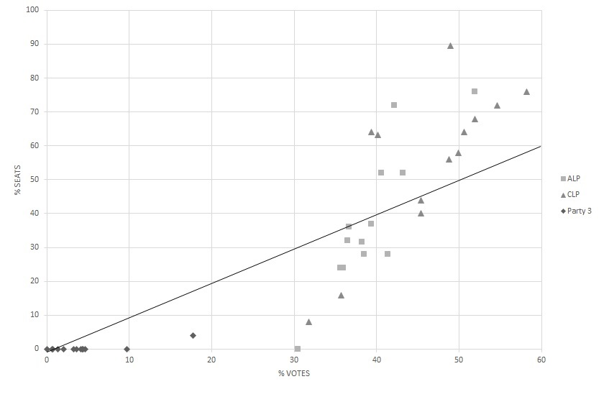
As parties with small vote shares win less than a proportional share of assembly seats in line with this law of minority attrition, it is also inevitable that some party or parties with a larger vote share must win more than a proportional share of seats compared to votes. This is manifest in Figure 1 in the 13 data points with vote shares between 39% and 60% sitting above the diagonal proportionality line. These are the winning major party in the 13 NTLA elections, the CLP in nine and ALP in four. It is also clear from Figure 1 that the losing major party in NTLA elections, with a vote share between 30% and 45%, wins less than a proportional share of seats, though seldom as far below the proportionality line as the party with the third most votes.

This pattern of divergence from seat-vote proportionality gives all proportionality profiles an S shape, having data points below the proportionality line to the left, above it to the right and a ‘break-even’ vote share somewhere in the middle. The shape of this S curve and location of the break-even vote share can, however, be unclear in this graph with a diagonal proportionality line. To improve clarity Taagepera and his collaborators in the 1980s developed the idea of graphing vote share against an advantage or disadvantage ratio measured by a party’s seat share divided by vote share. This changes the perfect proportionality line from a diagonal to a horizontal at value one and it accentuates the curve shape created by data points. Figure 2 graphs the 13 NTLA elections in this revised way, again for the ALP, CLP and the party with the third largest share of votes. Figure 2 also overlays these data points for NTLA elections with what Taagepera and Shugart identified as the curve shapes of four basic types of proportionality profile: flat, early rise, late rise and very late rise.

Flat and early rise profiles are expected in electoral systems that strive consciously for proportionality through large multi-member divisions and, in recent years, additional ‘list’ seats based on each party’s vote share. Late and very late rise profiles are expected in electoral systems which have stuck with local members of legislatures in divisions electing one representative, or possibly two or three. These basic curve shapes are the result of Taagepera and his associates thinking clearly about patterns of electoral results before adding data points. They are thus lines of empirically-informed deductive thought, not lines of best fit to any data points.

Figure 2. NTLA elections 1974-2016, three parties with horizontal proportionality line and four basic proportionality profile shapes.
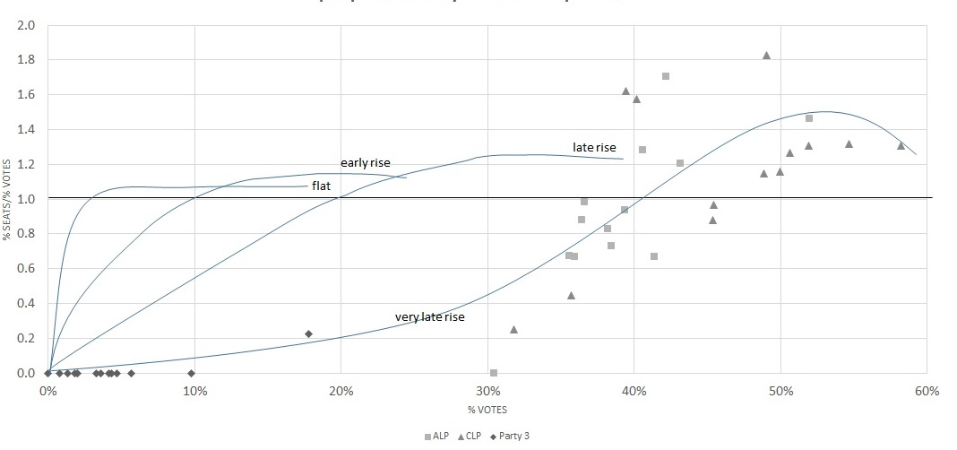

The proportionality profile for NTLA elections is closest to the ‘very late rise’ curve with a break-even vote share of around 40%. This is the expected proportionality profile for an electoral system using single-member divisions, as the Territory’s has since 1974. Three changes within that system during the period should be noted. First, as mentioned above, from 1980 enrolment and voting became compulsory for Aboriginal residents over 18, as for others. Second, the number of single-member divisions and hence seats in the NTLA was increased from 19 to 25 from 1983. Third, in 2016 there was a move to optional preferential vote marking, which effectively relaxed the rule for winning from a majority of ‘distributed’ votes to a plurality. None of these changes lessens the expectation that the NTLA would have a ‘very late rise’ proportionality profile, reflecting its single-member divisions.

The ‘very late rise’ proportionality profile is also to be expected in a strong two-party system, where third parties are seldom present in the assembly and one of the two major parties wins a majority of seats in almost all elections. This is well captured in Figure 2, with the two major parties to the right sitting above and below the proportionality line as they win and lose majority government, and the third party to the left only in one election winning a seat and rising off the x axis. However another aspect of NTLA elections that has not yet been graphically captured is the success of independent candidates.

There have been successful independent candidates in 11 of the 13 NTLA elections since 1974. Only in 1983 and 1997 have independents not won a seat. In the most recent NTLA election in 2016, independents did better than ever before, winning five of 25 seats, a seat share (20%) slightly higher than their vote share of 18.8%. Figure 3 adds 13 data points for independents in NTLA elections, treated as a group. It also adds election years to data points (except for ‘Party 3’), which enables us to see where the major parties and independents sit in relation to each other in any one election and also how they track through a sequence of elections.

Figure 3. NTLA elections 1974-2016, with independents and years added.
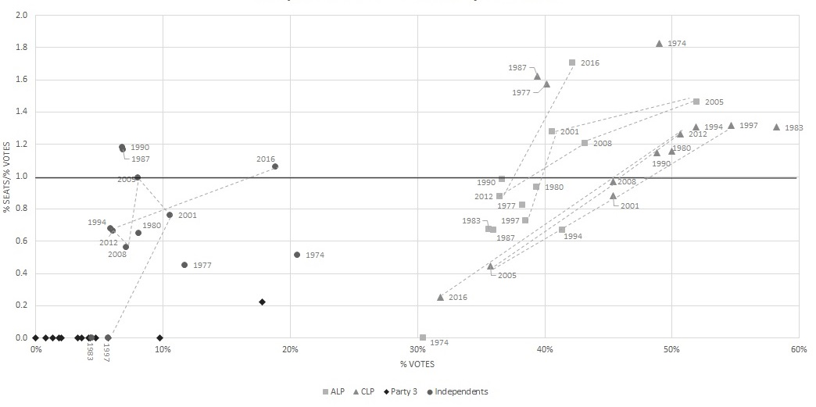

Unlike third parties, independents have contributed an ‘early peak’ of success in NTLA proportionality profiles, by often winning seats at vote shares of 5-20% across the jurisdiction. When just one or sometimes two independents have been successful, the seat share has been less than the vote share and hence the data point is under the horizontal proportionality line. However in three elections, 1987, 1990 and 2016, with two, two and five successful independents respectively, the seat share has been above the vote share of independents and hence the data point is above the proportionality line, creating a distinct ‘early peak’ in the profile.

This ‘early peak’ of success in a proportionality profile at quite low vote shares before a ‘middle valley’ and then later rise was recognised by Taagepera and Shugart as a pattern that emerges in single-member electoral systems with highly regionalised parties. They saw it as a variant of their ‘very late rise’ proportionality profile well illustrated by regional parties in Canada and the National Party in Australia. Such parties can gain assembly seats in their regions of voter concentration while having quite low vote shares across the whole jurisdiction. That independents in the Northern Territory succeed in a similar way suggests that they function like one-person local parties within their electoral divisions. A ‘local notable’ is a greater threat to the major parties in the Northern Territory’s single-member electoral districts than is a third ideological party. However the success of independents has also reflected what was going on within the two major parties, as can be illustrated by thinking about the two NTLA elections in which independents and a third party have won most seats, 1987 and 2016.

During the parliamentary terms leading up to the 1987 and 2016 elections, the governing CLP experienced major divisions, defections and a change of Chief Minister. Both successful independents in 1987 were former CLP members of the NTLA who had split from the party and so too was the successful National Party candidate, who was a former CLP Chief Minister. In 2016, three of the five successful independents were former CLP members of the NTLA, including a former Chief Minister and Deputy Chief Minister. While ‘CLP splitters’ have been the majority of successful independents in NTLA elections, there have been others as well whose success needs to be analysed. This is done later, using tabular analysis of electoral divisions. But first, the use of proportionality profiles to analyse NTLA elections jurisdiction-wide can be taken somewhat further.

In Figure 3, years next to data points allow us to observe the relative proportionality positions of the major parties and independents in each election. In the elections of 1980, 1990, 2001, 2008 and 2012, the two major parties can be observed to achieve assembly seat distributions in the proportionality range of 0.85 to 1.3. In these relatively close elections, neither major party fell below winning seven NTLA seats or rose above winning 16. By contrast landslide elections in 1974, 2005 and 2016 can be seen as placing the major parties much further above and below the seat/vote proportionality line. The losing major party in these three landslide elections fell to winning zero, four and two NTLA seats respectively while still attracting over 30% of votes, a seat-vote ratio of 0.4 or less. The winning party, by contrast, won 17 seats or more and achieved a seat/vote ratio of 1.5 or above. This is typical of landslide elections in single-member electoral systems.

Election years also allow us to track the changing proportionality positions of parties in a series of elections, like in a child’s join-the-dots picture book. Rather than join all the dots from 1974 to 2016 and turn Figure 3 into a jumble, dotted lines are restricted to a run of elections from 1997 to 2016. Three dotted lines can be followed showing the changing fortunes of the ALP, the CLP and independents in six elections.

Independents started from no assembly seats after the 1997 election moving up towards the proportionality line in 2001 and 2005 when they won two seats (8%) with 8-10% of votes. In 2008 and 2012 independents dropped well below the proportionality line winning only one seat (4%) with 6-7% of votes, before in 2016 breaking through the proportionality line by winning five of 25 seats (20%) with 18.8% of votes.

The CLP path in these six elections went from being a substantial above-the-line winner with well over 50% of votes in 1997 to a modest below-the-line loser in 2001, to the 2005 wipe out of winning only four of 25 seats (16%) with 35.7% of votes. In 2008 the CLP had another modest below-the-line loss before in 2012 being a modest above-the-line winner with just over 50% of votes. In 2016, however, the CLP plummeted further below the proportionality line and to a lower vote share than ever before, winning only two of 25 seats (8%) on the basis of 31.8% of votes.

The ALP path through these six elections is a near mirror image of the CLP’s. Modestly below the proportionality line in 1997, modestly above in 2001, more strongly above and with a higher vote share (51.9%) in the 2005 landslide win, then modestly above again in 2008, before losing in 2012 and falling just below the proportionality line. In 2016, as landslide winners, the ALP moved higher above the proportionality line than ever before, winning 18 of 25 seats (72%), but only on the basis of 42.2% of votes.

Figure 3 gives a good summary understanding of all 13 Northern Territory elections and how they compare to each other. Five close elections in which the two major parties sit near the proportionality line can be distinguished from three landslide elections with more distant data points, plus five more middling elections. The variable success of independents and third parties at low vote shares can also be clearly seen, usually well below the seat/vote proportionality line, but just occasionally rising towards or above it.

Where do independents succeed? A ‘lopsided seats’ hypothesis
While independents have been elected to the NTLA on 20 occasions in 11 of the 13 elections since 1974, the numbers of individuals elected is just 10, due to the repeated success of particular independents in consecutive elections. Table 1 is an attempt to discern in what sorts of electoral divisions of the Northern Territory independents have been successful. Vertically it groups NTLA divisions into five geographic categories ranging from urban Darwin and the Darwin rural area, through to regional towns and then remote Aboriginal-majority divisions, sometimes mixed together. Horizontally the left five columns of Table 1 show the changing numbers of electoral divisions in these geographic categories with redistributions of NTLA seats over the five decades. The right two columns show where the 10 successful independents have been elected, in what election year originally and for how many electoral terms (numbers in brackets adding to 20 terms in all). These right two columns also divide the 10 successful independents into six CLP splitters and four others.

Table 1. Independents elected by five categories of NTLA divisions
Geographic category of NTLA division | 19 Divisions from 1974 | 25 Divisions from 1983 | 25 Divisions from 1990 | 25 Divisions  from 2015 |  | Year CLP splitters originally elected (terms) | Year other independents  originally elected  (terms)
Darwin urban | 9 | 12 | 12 | 13 |  | 2016(1) | 1974(1)  1974(3)
Darwin rural |  | 1 | 2 | 2 |  | 1987(3) 2016(1) | 2001(5)
Regional Town | 2 | 4 | 4 | 3 |  | 1987(2) 2001(2) 2016(1)
Mixed Small Regional Town & Remote | 4 | 4 | 3 | 3 |  |  | 2016(1)
Remote Aboriginal- majority | 4 | 4 | 4 | 4

An initial scan of these right two columns of Table 1 may suggests that successful independents have been geographically dispersed across the Territory, three in urban Darwin, three in the rural area around Darwin, three in regional towns and one in a mixed small regional town/remote division. However, given that urban Darwin accounts for half of NTLA divisions, independents are in fact under-represented in the capital city. After the two initial Darwin independents were elected in 1974 and enjoyed electoral careers of one and three terms, there have been no more Darwin-based independents until 2016. This recent Darwin independent is a deposed ex-CLP Chief Minister, Terry Mills, who staged a belated political resurrection as an independent in 2016 in the outer suburban division of Blain.

Table 2 gives election statistics for the division of Blain back to its creation in 1997. In the five elections prior to 2016, this outer urban Darwin seat had always been won by the CLP. Indeed the CLP vote had been greater than 60% in four of these five elections (1997, 2001, 2008, 2012) and greater than twice the ALP’s in two. Even in the ALP’s 2005 landslide win, when it won all other Darwin urban seats, in Blain its vote was still 13.9% less than the CLP’s. The division of Blain has thus been such a safe CLP seat that it could be described as ‘lopsided’ in two-party terms. The ALP has had little if any prospect of winning Blain and the large difference between ALP and CLP support has opened up the possibility of precisely what happened in 2016 – a disaffected member splitting from the CLP and running successfully as an independent candidate. While coming second behind the ALP on primary votes, the independent Mills could attract enough preference votes from the eliminated CLP candidate to pass the ALP candidate and win. This too reflects the lopsided and deeply divided nature of Blain in two-party terms. Many CLP voters simply will not cross the ideological divide and give their preference vote to the ALP. They prefer to direct their preference vote to an independent, even one who is a CLP defector like Mills. The major party divide among voters in Blain is clearly very strong.

Table 2. NTLA Division of Blain, Election Statistics 1997-2016.
 | ALP | CLP | 3rd party | Independent | Formal | Informal | Enrolled | Turnout
1997 | 26.2% | 73.8%* |  |  | 3375 | 7.1% | 4091 | 88.8%
2001 | 29.3% | 64.0%* | 6.8% |  | 3662 | 3.8% | 4353 | 87.5%
2005 | 38.0% | 51.9%* | 7.3% | 2.8% | 3725 | 3.5% | 4475 | 86.3%
2008 | 38.4% | 61.6%* |  |  | 3668 | 5.1% | 4825 | 80.1%
2012 | 33.6% | 61.6%* | 4.9% |  | 3999 | 3.4% | 4980 | 83.2%
2016 | 37.3% | 25.7% | 5.6% | 31.3%* | 4281 | 2.7% | 5576 | 79.0%
*winner

The Blain experience can be used to formulate a more general hypothesis about successful independents in NTLA elections: that they emerge in divisions that are so safe for one of the major parties and so weak for the other that these divisions are effectively ‘lopsided’ in two-party terms. If we define a lopsided seat as one in which one major party has more than twice the vote share of the other in a recent election, then all five divisions in which independents were successful in 2016 support this hypothesis.

The division of Nelson, created in 1990, is one of two in the Darwin rural area. Together with its predecessor Koolpinyah in the 1983 and 1987 elections, this Darwin rural area division accounts for eight independent wins in the 10 elections since the NTLA was enlarged to 25 seats in 1983. Table 3 gives election statistics for Koolpinyah/Nelson spanning these 10 elections. The lopsided nature of the division can be seen immediately in 1983, when the CLP commanded 62.3% of votes, compared to the ALP’s 23.4%, a ratio of almost 2.7. While this made the division safe for the CLP in competition with the ALP, it also made the CLP vulnerable to competition from independents with centrist credibility, as shown in the results of eight of the next nine elections. Nelson is not in fact a safe seat for the CLP, but rather a lopsided one in which the ALP is so weak, that independents are a constant danger and real competitor for the CLP.

While lopsidedness in Koolpinyah/Nelson was harder to see during the three successful terms of CLP-splitter independent Noel Padgham-Purich from 1987 to 1994, it re-emerged clearly in 1997 when the CLP won 44.5% of votes compared to the ALP’s 19.8%, a ratio of 2.2. In 2001, local government identity Gerry Wood emerged as a new successful centrist independent in Nelson, at first by taking votes from the ALP, but over time also from the CLP (see Table 3). In 2016 Wood succeeded in winning Nelson for a fifth consecutive election, becoming clearly the NTLAs most successful independent yet.

Table 3. NTLA Division of Koolpinyah/Nelson, Election Statistics 1983-2016
 | ALP | CLP | 3rd party | Independent | Formal | Informal | Enrolled | Turnout
1983 | 23.4% | 62.3%* | 7.8% | 6.2% | 2234 | 1.5% | 2360 | 96.1%
1987 | 24.0% | 21.5% | 21.9% | 32.6%* | 2269 | 1.9% | 2936 | 78.0%
1990 | 32.8% | 20.0% |  | 41.0%* | 2942 | 1.7% | 3331 | 89.9%
1994 | 24.7% | 43.7% |  | 31.5%* | 3494 | 2.1% | 4006 | 89.1%
1997 | 19.8% | 44.5%* |  | 35.8% | 3281 | 3.4% | 3869 | 87.8%
2001 | 9.7% | 43.5% |  | 41.4%* | 3525 | 2.7% | 4049 | 89.5%
2005 | 12.6% | 30.8% |  | 56.6%* | 3771 | 2.3% | 4628 | 83.4%
2008 | 8.7% | 19.1% |  | 72.2%* | 3374 | 2.4% | 4635 | 74.6%
2012 | 6.9% | 39.9% |  | 54.0%* | 3679 | 1.9% | 4715 | 79.6%
2016 | 11.0% | 22.2% | 5.3% | 60.5%* | 4635 | 1.3% | 5825 | 80.6%
*winner

The second Darwin rural area seat of Goyder, created in 1990, can also be seen as lopsided, though less so than Blain and Koolpinyah/Nelson. Table 4 shows that, in eight elections, the ALP has only won Goyder once, in its 2005 landslide. It also shows that the CLP received more than double the ALP’s proportion of votes in two elections, 2001 and 2012. The CLP member for Goyder since 2008, Kezia Purick, became speaker of the NTLA after the 2012 election and survived in that position after splitting from the CLP as an independent in July 2015. That Purick won easily as an independent candidate in 2016 with a comfortable majority of the primary vote should not have been a surprise. Indeed, she was building on her mother’s example in 1987 in the seat of Koolpinyah. Two successful CLP-splitter independents in two generations of one family in the Darwin rural area suggests an electoral pattern, rather than just happenstance or luck. Padgham-Purich’s success in three consecutive elections as an independent in Koolpinyah/Nelson augurs well for her daughter’s electoral future in Goyder.

Table 4. NTLA Division of Goyder, Election Statistics 1990-2016.
 | ALP | CLP | 3rd party | Independent | Formal | Informal | Enrolled | Turnout
1990 | 22.7% | 42.7%* | 9.5% | 13.2% | 2506 | 3.3% | 3113 | 83.3%
1994 | 31.4% | 53.7%* |  | 14.9% | 3316 | 2.4% | 4120 | 82.4%
1997 | 34.4% | 59.4%* |  | 6.1% | 3106 | 4.1% | 3904 | 83.0%
2001 | 27.2% | 57.7%* | 7.5% | 7.5% | 3623 | 3.3% | 4358 | 85.9%
2005 | 35.7%* | 35.3% | 6.4% | 13.9% | 3854 | 3.3% | 4491 | 88.8%
2008 | 41.6% | 58.4%* |  |  | 3739 | 4.3% | 4699 | 83.2%
2012 | 29.4% | 62.2%* |  | 8.9% | 4391 | 3.1% | 5323 | 85.2%
2016 | 18.9% | 20.2% | 4.1% | 55.0%* | 4539 | 1.7% | 5586 | 82.6%
*winner

The seat of Araluen in the regional town of Alice Springs provides an even clearer instance of a lopsided division. Since its creation in 1983, Araluen has been won consistently by the CLP, with a proportion of votes more than double the ALP’s on six occasions (1983, 1990, 1994, 1997, 2008, 2012) (see Table 5). There was thus plenty of room for former CLP Deputy Chief Minister Robyn Lambley to become a splitter independent and attract enough votes to win in 2016. Although Lambley needed to rely on ALP preferences, she was already the front runner after primary votes and went on to win easily. One would think that, like the two earlier CLP-splitter independents in the regional town of Alice Springs (see Table 1), Lambley too would have good prospects of re-election for a second term as an independent, should she choose to stand in 2020.

Table 5. NTLA Division of Araluen, Election Statistics 1983-2016.
 | ALP | CLP | 3rd party | Independent | Formal | Informal | Enrolled | Turnout
1983 | 17.9% | 61.7%* |  | 20.4% | 2056 | 1.4% | 2341 | 89.1%
1987 | 28.9% | 43.6%* | 27.5% |  | 1998 | 2.7% | 2657 | 77.3%
1990 | 24.5% | 57.1%* | 18.4% |  | 2863 | 2.5% | 3406 | 86.2%
1994 | 29.9% | 70.1%* |  |  | 2983 | 4.5% | 3747 | 83.3%
1997 | 30.8% | 69.2%* |  |  | 2984 | 7.0% | 3814 | 84.1%
2001 | 32.4% | 41.1%* | 13.3% | 13.2% | 3374 | 4.4% | 4395 | 80.3%
2005 | 36.9% | 52.3%* | 9.2% |  | 3610 | 3.0% | 4532 | 81.1%
2008 | 17.7% | 68.3%* | 14.6% |  | 3614 | 2.4% | 4963 | 74.6%
2012 | 23.4% | 68.7%* | 7.9% |  | 3620 | 3.6% | 4817 | 78.0%
2016 | 24.7% | 36.4% |  | 38.9%* | 4720 | 2.1% | 5850 | 82.5%
*winner

Returning to Table 1 in light of Tables 2-5, it can be seen that the five/six NTLA divisions in regional towns and the Darwin rural area account for six of 10 successful independents and 14 of their 20 electoral terms. These divisions based on regional towns or the Darwin rural area are clearly the independent heartland of Northern Territory elections, built on lopsided two-party support away from the ALP and towards the CLP. Independents are far more of a threat to the CLP in these lopsided seats than is the ALP.

It is also notable in Table 1 that successful independents have not, until 2016, extended down into the bottom two more remote categories of NTLA divisions with more substantial proportions of Aboriginal voters. These seven ‘bush seats’ tend, in partisan terms, towards the ALP, but have all at some time in the past been won by the CLP. Indeed in its 2012 win, the CLP captured five of these bush seats, showing it could win Aboriginal votes away from the ALP. However in 2016 the CLP proceeded to loose four of its five bush seats back to the ALP, while the ALP lost one of its two (Nhulunbuy) to an independent. It is to this division of Nhulunbuy that I now turn in an attempt to think about Aboriginal votes, independent candidates and the lopsided seats hypothesis.

On the eastern tip of the Gove Peninsula, the NTLA division of Nhulunbuy has since 1974 included the small bauxite mining and refining town of the same name. Over time, with changing populations and redistributions, the division has also covered increasing areas of the Yolgnu hinterland. This process accelerated after Rio Tinto’s decision in late 2013 to close the alumina refinery at Nhulunbuy. With Nhulunbuy’s population in decline by over 1000 people, the 2015 redistribution of NTLA divisions saw the Yolngu communities of Millingimbi and Ramingining transferred from the division of Arnhem into Nhulunbuy (see Figure 4). This gave the division of Nhulunbuy a clear Aboriginal majority population, having previously had more of a 50/50 demography between Aboriginal voters and others.

Figure 4: Northern Territory Electoral Divisions 2016
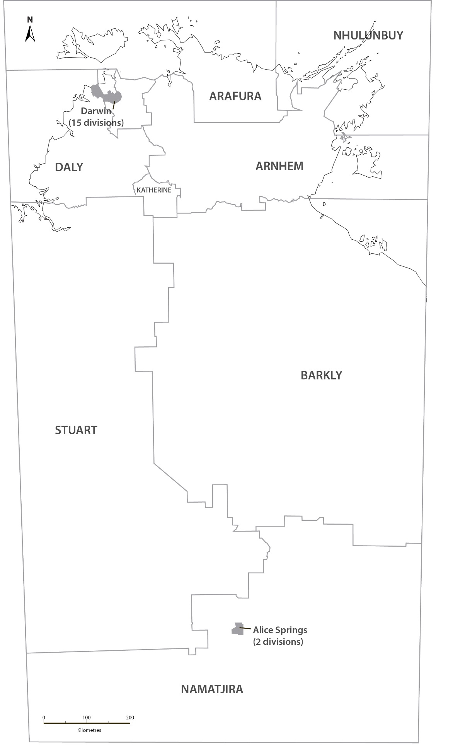
Source: Northern Territory Electoral Commission map simplified by John Hughes, Australian National University

Table 6 gives electoral statistics for Nhulunbuy back to 1974. While the CLP won Nhulunbuy in the first two NTLA elections, after 1980 this division became an increasingly safe ALP seat. In the five elections from 1997 to 2012 the ALP’s share of primary votes was consistently more than double the CLP’s. This large lopsided difference in support for the two major parties opens up possibilities for both defection and disenchantment. Independent candidates can potentially attract votes from dominant party supporters who feel neglected and from supporters of the dominated party who despair of ever winning.

Independents had contested elections in Nhulunbuy five times up to 2012, polling greater than 10% on three occasions and greater than 20% on two (see Table 6). Though unsuccessful in being elected, these past levels of voter support for independents gave a sense of what is possible. The win for the dominant ALP in the 2012 election was safe, but the independent polled almost as large a share of primary votes as the CLP. That 2012 independent, Kendall Trudgen, was from a prominent non-Indigenous family loosely affiliated with a group called the Yolgnu Nations Assembly. This Yolgnu first nation organisation held four major gatherings between October 2011 and August 2015, developing a written, registerable constitution in the process. The organisation then seemed ready to take a more public political profile. In April 2016, Yingiya Mark Guyula announced that he was standing for the NTLA seat of Nhulunbuy as an independent candidate ‘endorsed by the Yolgnu Nations Assembly’. Guyula had previously had some public profile as a Yolgnu Studies lecturer at Charles Darwin University who had spoken out against the Commonwealth’s Intervention in Northern Territory Aboriginal communities from 2007.

Table 6 shows that in his first attempt to be elected to the NTLA seat of Nhulunbuy as an independent first nation candidate, Guyula demonstrated just what is possible in a lopsided seat. Guyula attracted 41.6% of formal primary votes in the August 2016 election, at a cost of around 10% of their 2012 votes to both the CLP and ALP. This put Guyula in second place behind the dominant ALP, but able to draw on CLP preference votes to pass the ALP and win.

Table 6: NTLA Division of Nhulunbuy, Election Statistics 1974-2016.
 | ALP | CLP | 3rd party | Independent | Formal | Informal | Enrolment | Turnout
1974 | 41.1% | 48.3%* |  | 10.6% | 1362 | 3.6% | 1888 | 74.8%
1977 | 41.2% | 56.1%* | 2.8% |  | 1559 | 2.6% | 2122 | 75.4%
1980 | 43.2%* | 32.7% |  | 24.1% | 1874 | 3.4% | 2489 | 77.9%
1983 | 51.2%* | 48.8% |  |  | 1876 | 2.8% | 2484 | 77.7%
1987 | 45.9%* | 29.0% | 6.2% | 19.0% | 2255 | 2.6% | 3366 | 68.8%
1990 | 59.1%* | 40.9% |  |  | 2359 | 3.9% | 3197 | 76.8%
1994 | 54.6%* | 45.4% |  |  | 2474 | 5.7% | 3717 | 70.6%
1997 | 72.1%* | 27.9% |  |  | 2608 | 6.1% | 4152 | 66.9%
2001 | 54.9%* | 25.8% | 6.1% | 13.2% | 2677 | 5.3% | 4262 | 66.4%
2005 | 76.1%* | 23.9% |  |  | 2877 | 4.1% | 4606 | 65.1%
2008 | 74.2%* | 25.8% |  |  | 2610 | 3.8% | 4534 | 59.8%
2012 | 55.0%* | 22.7% |  | 22.3% | 2824 | 4.6% | 4719 | 62.7%
2016 | 44.4% | 13.1% |  | 41.5%* | 3385 | 2.1% | 5896 | 58.7%
*winner

Guyula’s win in Nhulunbuy in 2016 supports the lopsided seats hypothesis, but it is clearly very different from the other four instances of successful independents in the 2016 NTLA elections. While the other four seats were lopsided towards the CLP, Nhulunbuy was lopsided towards the ALP. Also, while Guyula stood as an independent, he did so with the endorsement of a Yolgnu first nation organisation. This attempt to draw on first nation identities and loyalties in NTLA elections was tried more generally, and unsuccessfully, in 2012 by the First Nations Peoples Party. In 2016 by contrast, Guyula succeeded by drawing on a single first nation identity and endorsing organisation. Fortuitously, Yolgnu country corresponded well with the NTLA division of Nhulunbuy in 2016, which had also become lopsided in two-party terms towards the ALP.

In his maiden speech to the NTLA, Guyula described himself as not just an ‘elected member’, but also a ‘diplomat from the Yolgnu Ngarra bringing two parliaments together’. As well as mutual recognition for the Ngarra as a Yolgnu parliament, Guyula also sought recognition for the Yolgnu’s ‘Madayin system of law’. The Yolgnu, he declared, ‘have not been conquered’, are ‘to this day… a sovereign people’ and have on numerous occasions sought a treaty and recognition from Australian governments. This is a very different approach to what Maddison in 2010 analysed as the ‘dilemmas of Indigenous parliamentary representation’ within the dominant geographic and party-based system. While representing an electorate which includes non-Indigenous people, Guyula is unconstrained by party concerns and is clearly prioritising his representation of an Indigenous first nation. How this plays out over time will be of great interest to observe.

Conclusion: Refining scholarship on independents in Australian parliamentary elections
While Australian parliamentary elections have long been dominated by parties, Costar and Curtin have documented a history and recent increase of successful independents. They relate this to both electoral systems and party systems. They argue that ‘compulsory, preferential voting in single-member districts aids the cause of independents’ because electoral divisions are ‘small enough to allow a candidate without the support of a party machine to assemble enough primary votes’ and because ‘Labor and the Coalition are more likely to direct preferences to independents than each other’. They also note that the seats independents have won ‘were previously “safe” for the losing party’ and that this loss has been most often at the Coalition’s expense in rural and regional areas, and less often at Labor’s expense.

My examination of the role of independents in NTLA elections is in agreement with Costar and Curtin’s more general analysis, with a slight refinement. The lopsided seats hypothesis suggests that it is very safe seats, in two-party terms, which are at risk of loss to an independent. It is the large difference in voter support between the two major parties that opens up possibilities for independents as serious third candidates. Independents in lopsided seats can attract dissatisfied voters from the dominant party (who feel neglected or taken for granted) and disenchanted voters from the dominated party (who despair of ever winning). If independents poll ahead of the dominated major party in the primary count, they can then rely on a good flow of preferences from voters unwilling to cross the major party divide.

While many rural and regional constituencies are lopsided towards the conservative parties, the NTLA reminds us that there can be instances of seats lopsided towards the ALP. Remote area divisions with majority Aboriginal populations have this potential. Nhulunbuy in the 2016 NTLA elections is a fascinating example of how this particular form of lopsidedness allowed a first nation independent candidate to succeed at the ALP’s expense. Whether this can occur again in the future among the NTLA’s seven bush seats with near or clear majority-Aboriginal populations, will also be of great interest to observe.

Coda on Future Research: Aboriginal enrolment and voting
Finally I note one more aspect of the 2016 Nhulunbuy contest; the low turnout of voters against the roll at 58.7% (see far right column of Table 6). As a strategist trying to win Nhulunbuy, one could argue that getting enrolees to vote is as important as attracting them away from other candidates. This is unusual in the Australian context of compulsory voting and it raises interesting questions about what is happening with Aboriginal enrolment and voting in the early 21st century, particularly in remote areas.

Kelly has noted that during the 2000s, compared the 1990s, there seemed to be a fall in voter turnout in electoral divisions with high Indigenous populations, both in federal parliamentary and NTLA elections. He speculated that this reflected the 1996 abolition of the Australian Electoral Commission’s Aboriginal and Torres Strait Islander Election Education and Information Service (ATSIEEIS). Kelly also held out hope that the 2009 reintroduction of an Indigenous Electoral Participation Program might raise turnout figures again in seats with high numbers of Indigenous voters. However, if the NTLA seat of Nhulunbuy is indicative, this does not seem to have happened by 2016. Voter turnout figures against enrolments in remote majority-Aboriginal divisions still seem low, both compared to the 1990s and before, and compared to urban and regional divisions with smaller Aboriginal populations (see far right columns of Table 2-5 compared to Table 6).

More analysis is needed to substantiate the claim that turnout figures are languishing in majority-Aboriginal divisions. Were this substantiated, it would also be open to different explanations. Perhaps, for example, having newly embraced voting in the 1980s and 1990s, Aboriginal people have since become somewhat disillusioned and less interested. But perhaps also electoral administrators are struggling to keep rolls clean and up-to-date in remote areas with high proportions of Indigenous enrolments. These two incipient hypotheses about Aboriginal electoral participation in the early 21st century are worthy of further development and research.

Acknowledgements and Funding
Alyson Wright and John Hughes assisted with figures for this article.
This work was undertaken as part of general university employment. No specific research funding was received.

Notes on Contributor
Will Sanders has researched north Australian and Indigenous issues since 1981, based in four departments of the Australian National University.

ORCID
Will Sanders 0000-0002-2524-0460

Brian Costar and Jennifer Curtin, Rebels with a Cause: Independents in Australian Politics (Sydney, 2004).
Community profiles on the website of the Australian Bureau of Statistics report usual resident population counts in the Northern Territory in the 2016 Census at 58,248 Aboriginal and/or Torres Strait Islander in a total of 228,833 (25.5%). Comparable figures for all Australia in the 2016 Census were 649,171 and 23,401,892 (2.8%). Henceforth I use the word Aboriginal to refer to the Indigenous people of Northern Territory since Torres Strait Islander issues are Indigenous to Queensland and do not loom as large in the Territory jurisdiction. This is generally reflected in the naming and word usage practices of Northern Territory Aboriginal organisations.
Alan Powell, Far Country: A Short History of the Northern Territory (Carlton, 1996).
Dean Jaensch and Peter Loveday eds. Elections in the Northern Territory 1974-1977 (Darwin, 1979, ANU North Australia Research Unit).
Peter Loveday, Alan Martin and Robert Parker eds, The Emergence of the Australian Party System (Sydney, 1977).
See Hilary Rumley’s chapter 6 in Jaensch and Loveday eds Elections in the Northern Territory 1974-1977.
Dean Jaensch and Peter Loveday eds, Under One Flag: The 1980 Northern Territory Election (North Sydney, 1981, pp.21&61.
Peter Loveday and Dean Jaensch eds, A Landslide Election: The NT 1983 (Darwin, 1984, ANU North Australia Research Unit). Dean Jaensch and Peter Loveday eds, Challenge from the Nationals: The Territory Election 1987 (Darwin, 1987, ANU North Australia Research Unit). Peter Loveday, Dean Jaensch and Baiba Berzins, Labor’s Win: The Northern Territory Election 2001 (Sydney, 2002).
Will Sanders, “The 2001 Northern Territory Election: the end of an era, a victory for Labor and for two-party democracy”, Australian Quarterly: Journal of Contemporary Analysis, Vol 73,6 (2001), pp.22-27. Will Sanders, “Labor’s Landslide, CLP’s Tsunami: The 2005 Northern Territory Election”, Australian Quarterly: Journal of Contemporary Analysis, Vol 77,3 (2005), pp.4-6. Will Sanders, “Winning Aboriginal Votes: Reflections on the 2012 Northern Territory Election”, Australian Journal of Political Science, Vol 47,4 (2012) pp.691-701.
Rein Taagepera and Marku Laakso, “Proportionality Profiles of West European Electoral Systems”, European Journal of Political Research, Vol. 8 (1980), pp423-446. Rein Taagepera and Matthew Shugart, Seats and Votes: The Effects and Determinants of Electoral Systems (New Haven and London, 1989).
In Australian terminology these are shares of ‘primary’ votes expressing a No1 preferences for a candidate or party, not final ‘distributed’ vote shares. Electoral systems in most countries do not have this distinction between primary and distributed votes as ballots are simply marked categorically. Australia’s enthusiasm for preferential vote marking with numbers is unusual and leads to some additional fine points of distinction with the international literature on electoral systems.
See Taagepera and Shugart, Seats and Votes, p.188.
Taagepera and Shugart, Seats and Votes, p.70.
In giving talks about this work, this is the point of clarification about proportionality profiles that arises most often in questions and discussion. It was also raised by one of the reviewers of this article.
Optional preferential voting was also used in 1974, but changed to full preferential from 1977. See Jaensch’s chapters 7 and 10 in Jaensch and Loveday eds, Elections in the Northern Territory 1974-1977. See footnote 11 for the distinction between ‘primary’ and ‘distributed’ votes in the preferential electoral systems used in Australia.
Taagepera and Shugart, Seats and Votes, p73.
See chapters 1 and 5 in Jaensch and Loveday eds, Challenge from the Nationals.
For an account of how the CLP government elected in 2012 divided and destroyed itself, see Ben Smee and Christopher Walsh, Crocs in the Cabinet: Northern Territory politics – An instruction guide on how not to run a government (Sydney, 2016).
In this analysis, 1983 is seen as a middling election in which the CLP won 19 seats and the ALP 6, giving seat/vote ratios of 1.31 and 0.67 respectively. At the time Loveday and Jaensch described 1983 as a landslide election, which in many ways it was. Because only the two major parties won seats in 1983, their seat/vote ratios were not as high and low as in other landslide elections. Also note from Figure 3 that the CLP’s vote share was at its highest in 1983 (58.2%) and the ALP’s at its lowest (35.6%) but for 1974 (30.5%). Loveday and Jaensch were justified in describing 1983 as a landslide election, but these big differences in the vote share of the major parties and the lack of independent success mean that 1983 does not stand out as a landslide in the NTLA proportionality profile.
Mills resigned from the NTLA in March 2014, one year after having been deposed as Chief Minister by Adam Giles. His 2016 independent candidature for Blain was announced only three weeks before the August election.
See chapter 18 ‘Woman Trouble’ in Smee and Walsh, Crocs in the Cabinet.
Sanders, “Winning Aboriginal Votes”.
Amos Aikman, “A town stares into the abyss as refinery closes” The Weekend Australian, 7-8 December 2013. Matthew Stevens, “It’s all over for Gove refinery” The Financial Review, 27 November 2013.
Sanders, “Winning Aboriginal Votes” gives the comparable map of divisions for the 2012 NTLA elections.
In the 2016 Census the Australian Bureau of Statistics counted 9529 usual residents in the Nhulunbuy electoral division, 6308 (66.2%) of whom identified as Aboriginal and/or Torres Strait Islander. See Indigenous Community Profiles on the Census section of the website of the Australian Bureau of Statistics.
http://www.yolngunations.org/
https://indigenousx.com.au/why-i-am-running-in-the-northern-territory-elections-yingiya-mark-guyula/#.WxipQme-mUk
See Yingiya Mark Guyula, “A Statement, June 2011” in Rosie Scott and Anita Heiss, The Intervention: An Anthology (Sydney, 2016), pp.57-60.
Sanders, “Winning Aboriginal Votes”.
http://www.ethos.org.au/online-resources/blog/yingiya-mark-guyula-mla-s-first-speech-in-nt-parliament
Sarah Maddison, “White Parliament, Black Politics: The Dilemmas of Indigenous Parliamentary Representation”, Australian Journal of Political Science, Vol 45, 4 (2010), pp663-680.
Costar and Curtin, Rebels with a Cause, p.10.
Norm Kelly, Directions in Australian Electoral Reform: Professionalism and Partisanship in Electoral Management (Canberra, 2012), p.67.
For the beginnings of such research and analysis see Will Sanders, Electoral Administration and Aboriginal Voting Power in the Northern Territory: Reality and Potential as viewed from the 2019 Federal Election, Working Paper 132, Australian National University Centre for Aboriginal Economic Policy Research, 2019. https://caepr.cass.anu.edu.au/research/publications/electoral-administration-and-aboriginal-voting-power-northern-territory

