Cassie-Levitated Droplets for Distortion-Free Low Energy Solid-Liquid Interactions

William S. Y. Wong¹* and Antonio Tricoli¹*

¹ Nanotechnology Research Laboratory, Research School of Engineering, The Australian National University, Canberra ACT 2601, Australia

Keywords: Cassie-Levitated, Superamphiphobicity, Distortion-free, Bashforth-Adams Profile, Pendant droplet

*corresponding authors: antonio.tricoli@anu.edu.au; william.wong@anu.edu.au
Abstract
Despite the rapid advent of superomniphobic materials, there is a lack of methodologies to accurately investigate the ultra-low energy interactions taking place on these interfaces. For instance, universally-employed models such as the pendant droplet often fail to provide representative information of the wetting properties of superomniphobic surfaces. The delicate balance between the forces acting at the droplet-surface and droplet-needle interfaces can easily result in heavily distorted droplet profiles. Here, we introduce a Cassie-Levitating droplet model, which overcomes the limitations of the pendant droplet model, allowing a distortion-free assessment of the interactions between super(amphi)omniphobic materials and low surface tension liquids. Comparative analysis in wetting of low surface tension fluids such as hexadecane (~27.47 mN/m) on superamphiphobic surfaces via the Cassie-Levitating and pendant droplet models reveal up to 70° (800%) deviations in the estimated contact angle hysteresis. A theoretical framework is developed to assess experimentally observed profile distortions against ideal gravity-induced sagging of droplet shapes during dynamic droplet expansion and contraction cycles. Notably, pendant droplets resulted in up to 50% distortion while the Cassie-Levitating ones achieved less than just 10%. We believe that the Cassie-Levitating droplet model bears ample potential for the characterization of the rapidly emerging family of superomniphobic materials, setting the basis for their future engineering in numerous emerging applications.

Introduction
Ultra-liquid repellent surfaces are the focus of a rapidly increasing research effort.¹⁻⁵ This class of materials is classified in superhydrophobic,⁶ superoleo(amphi)phobic^{1,7,8} and superomniphobic surfaces^{3,9,10} as a function of the surface tension of the liquid that they are able to repel. However, understanding of the ultra-low energy solid-liquid interactions taking place on superamphi- and omniphobic surfaces is limited by the development of appropriate analytical approaches and theoretical frameworks.^{3,11-13} Good et al. has thoroughly investigated the relationship between droplet size and contact angle.¹⁴ Kang and Jacobi studied the interaction between contact angle and surface energy on ideal rough solids which are similar to some of the superamphiphobic surfaces investigated here.¹⁵ For instance, the pendant droplet model is one of the primary methods for the analysis of solid-liquid interactions.^{13,16} This involves the formation of a pendant droplet with an accurately controlled volume, which is thereafter placed in contact with a material surface thus forming a sessile droplet. Static contact angle (CA) measurements are obtained directly from the sessile droplet-on-surface image, while contact angle hysteresis (CAH) measurements are achieved by controlled droplet-expansion and contraction cycles. However, the applicability of the pendant droplet model for emerging superamphi- and omniphobic surfaces seems limited.^{17,18}
Notably, with the progress in ultra-liquid repellent materials, the surface energy of probe liquids has decreased significantly, reaching down to 20-27.5 mN/m for superamphiphobic surfaces and as low as 10 mN/m for superomniphobic ones.^{1,3,19} As a result, when pendant droplets of ultra-low surface energy liquids are formed, the liquids tend to wet and creep up the sides of the needles, which typically possess relatively high surface energies of 700-1100 mN/m.^{11,17,18,20} Coupled to the lack of adhesion on superamphi- and omni-phobic surfaces, the sessile droplet experiences predominant needle-to-liquid adhesion. This culminates in largely distorted,^{17,21,22} prolate²⁰ or asymmetrical¹⁷ droplet profiles, which are not representative of the solid-liquid interactions.
Significant efforts are being directed towards overcoming these limitations.^{11,12,17,21,22} Recent apex-free profile fitting methods^{21,22} have shown enhanced measurement accuracy for needle-inside-droplet profiles for low contact angles (ca. 60-70°). However, large contact angles, as those expected for liquid-repellent materials, are known to be much more sensitive to apex perturbations.^{12,21,22} Other approaches exploit optical magnification for micro- and macro- contact angle fitting.¹⁷ However, they seem to suffer from poor droplet symmetry. In order to enhance receding contact angle (ReCA) sensitivity, the use of much larger hysteresis cycles that ranged up to 7 times the normal volume, have also been considered.¹¹ Unfortunately, this method has only been successfully demonstrated with water, while low-surface tension liquids continue to induce severe profile distortions even with large volumes. Complete revision of the fitting algorithms to account for droplet distortion in standard goniometric instruments is also being pursued and is showing promising results for static measurements.¹² Notably, despite much progress, accurate determination of ultra-low surface energy interactions between solid-liquid interfaces via dynamic droplet expansion and contraction cycles is, in many cases, not possible. In light of the growing research and industrial interest in ultra-liquid repellent materials,^{19,23-25} it is of paramount importance to realize facile and accurate analytical approaches for their characterization.
Here, we present a novel methodology and theoretical framework to investigate the ultra-low surface energy interactions between ultra-repellent materials and associated liquids. A perturbation-free system was developed by establishing a quasi-ideal Cassie-levitated droplet model (CLM) that resolves the distortion factors acting on the pendant droplet model. The CLM is induced by imparting a Cassie-Baxter’s state of low-fractional wetting to the needle pinning point while shifting the pinning force from an orthogonal to the parrallel imaging plane. This results in an unprecedented demonstration of a symmetric droplet system that is capable of full profile-matching against the Bashforth-Adams model. Average fitting errors of less than 5% were accurately achieved down to droplets of 100 nL. In addition to enhanced profiling sensitivity, accuracy and operational simplicity, the approach demonstrated here provide a highly required, easily applicable tool to investigate the properties of superoleophobic, superamphiphobic and superomniphobic materials.

Results and Discussion

From the Pedant to the Cassie- Levitated Droplet Model
One of the most established approaches for quantifying the interaction of a surface with a liquid is based on the use of pendant droplets, which form sessile droplets when released on the investigated surface. This is also the basis of more recent contact angle hysteresis approaches, where a pendant droplet is expanded and then contracted on a surface, enabling a comprehensive assessment of the surface’s chemical and physical heterogeneities. The successful use of pendant droplets requires minimizing needle-to-liquid adhesive forces so as to avoid profile disruptions. However, with the advent of superoleo-, amphi- and omni-phobic surfaces, the use of ultra-low surface tension liquids results in significant interactions between the droplet and the needle used for its manipulation. This culminates in undesirable forces along the vertical axis that distort the pendant droplet shape from an oblate to a prolate profile. Figure 1a shows a schematic representation of the ideal and distorted pendant droplet profiles, and the Cassie-levitated droplet model developed here. The distorted pendant droplet is commonly observed with standard steel needles, with the distortion of droplet shapes during both droplet expansion and contraction. It is the most commonly implemented characterization method, but it cannot be reliably applied to the characterization of ultra-low energy interaction. Figure 1b shows an exemplary state of droplet distortion by trying to use the pendant droplet method to characterize the interaction of hexadecane on an adhesive superamphiphobic surface.
The ideal pendant droplet is achieved via a less wettable needle (Figure 1a), but is still strongly influenced by the needle wetting forces during droplet evolution (i.e. expansion compression-induced creep). Distorted profiles occur primarily during receding droplet tests. The pendulum droplet exploits a contact-free Cassie-Baxter (CB) state at the needle’s contact point, and should be potentially capable of achieving natural droplet growth-decay profiles. However, it experiences forces acting on the vertical plane and requires dynamic optimization of the needle-to-surface distance during contact angle hysteresis measurements. This optimization, usually preformed manually by the user, is not trivial as repulsive forces are experienced by compressed droplets during the droplet expansion part of the cycle, giving rise to excessively flattened oblate droplets. Similarly, during droplet contraction, the minute adhesion forces exerted by the thin capillary tether can result in drawn-out, cylindrically shaped prolate droplets.
The Cassie-levitated droplet developed here represents the theoretically ideal model where there are no needle-to-droplet forces acting on the Y-Z imaging plane. In this model, forces induced by the capillary tether are eliminated by an axial-rotation of the needle. Notably, in contrast to the Cassie-levitated model (Figure 1 e-g), the distorted pendant model cannot achieve a distortion free imaging plane by simple rotation of the needle axis (Figure 1 b-d) as strong adhesion of the liquid to the needle dominates the resulting profile. For instance, angling by 25° leads to pushing of the droplet upwards against the needle (Figure 1c). Full rotation by 90° leads to further distortion, culminating in a droplet that is elongated in the X-axis, pinned at two locations, the tip and the bent portion of the needle (Figure 1d).
In stark contrast, the Cassie-levitated model leads to elimination of adhesive forces between the needle-to-liquid interface, allowing the cohesive forces within the droplet to evolve naturally under the influence of the solid surface and gravity (Figure 1 e-g). The thin capillary tether within the in-needle channel holds onto the droplet, preventing on-surface motion. However, the needle-to-droplet forces are shifted from the vertical plane to a plane orthogonal to the imaging one (Figure 1f-g). As a result, the droplet is only loosely tethered to the needle, and is kept in a quasi-levitated fractional contact mode (Figure 1g).
A Theoretical Framework for the Cassie-Levitated Droplet Model

A theoretical framework for the utilization of the Cassie-levitated droplets was implemented alongside the contact angle hysteresis methodology. Figure 2a shows a full expansion/contraction cycle for the established pendant droplet model. Excessive needle-to-liquid adhesion results initially in a distended prolate droplet. Increasing droplet volume improves the spherical profile, but the adhesive distortion near the droplet-needle interface remains. This vertical pull results in a slightly lifted droplet. As a result, contact lines governing the droplet-needle interface exert a non-negligible impact on the droplet profile throughout the entire dynamic contact angle analysis cycle. Notably, deformations induced on the droplet free surface and interfacial contact lines are the most severe at the beginning and at the end of the cycle, when the droplets are small.
In stark contrast, we have observed that in the Cassie-levitated model, the evolution of contact angle profiles is directed by the natural growth and contraction of the droplet, with no observable impact from the needle’s interaction. This allows its profile evolution during the expansion-contraction cycle to be a representative measure of the surface’s heterogeneities. Figure 2a shows that in the Cassie-levitated model, small initial droplets have a quasi-perfect spherical shape. Volumetric growth of the droplet from 0.1 to 11 μL generates a quasi-ideal oblate profile corresponding to gravity-induced sagging. During the droplet contraction step of the cycle, receding contact lines develop naturally without any indication of external stresses induced by the needle on the droplet’s free surface.
A model for the above observations is proposed by computation of the forces acting on these model droplets: the ideal pendant; the pendulum; the superamphiphobic Cassie-levitated and the orthogonal pendant. Models were developed based on the needles’ surface wetting parameters (Equations S2-5).^{8,26} The adhesion forces acting on the needle for each model droplet are computed with respect to the vertical Z-axis, which has the strongest impact on droplet profile distortion (Figure 2b). For the Cassie levitated model, the superamphiphobic needle connected orthogonally to the back of the droplet results in no forces acting along the Y-Z imaging plane.
For the ideal pendant model, the use of an amphiphobic needle reduces the droplet-needle adhesion forces. However, the needle remains wettable, resulting in upward drawing forces thus leading to profile distortion in the imaging plane. This effect is known to occur within pendant droplet profiles and decreases when approaching a superamphiphobic state. For the pendulum model, the use of superamphiphobicity eliminates any static adhesion forces by virtue of fractional contact. However, it suffers from dynamic vertical forces, stemming from capillary tether strain and droplet compression (Figure S22). The former exists with a hanging droplet (full or partial gravitational pull), while the latter is induced when a droplet is pressed against a superamphiphobic surface. Unrelaxed droplet compression between the needle and test surface leads to spikes in the vertical forces (Figure S21). It results in droplet profile distortion and thus inaccuracies in contact angle measurements. The pendulum model can achieve a near-ideal droplet profile if the needle-to-surface heights are dynamically optimized to control stress-strain behaviors within the liquid droplet. However, this is very difficult to attain during early-and-final stages of droplet expansion-contraction. The orthogonal pendant model is derived by axially rotating the classical pendant droplet by 90°, but it results in liquid creep along the needle. Despite the absence of vertical forces, horizontal adhesion forces dominate (Figure S18), resulting in distortion of the droplet free surface and an elongated liquid droplet (Figure 1) with significant contact angle variations.
Investigation of Ultra-Repellent Materials with the Cassie-Levitated Droplet Model
The effectiveness of the Cassie levitated model was evaluated via contact angle hysteresis measurements on a series of low energy surfaces that ranged from amphiphobic to superamphiphobic variants (Figure 2c). The relative adhesion was computed by a model that determines the surface retentive force based on dynamic wetting properties of a substrate (Equation S1).²⁷ The detailed fabrication⁷ of these surfaces is described in the Supporting Information under Materials and Methods. Comparative CAH measurements were obtained with the pendant droplet and Cassie-Levitated model on the same surfaces. Surface amphiphobicity affects both the receding contact angle (ReCA) and advancing contact angle (ACA), and thus the CAH. The ReCA and ACA measurements were performed at a speed of 0.1 µL/s (Supporting Information, Materials and Methods). These dynamic wetting parameters enable the analytical computation of the adhesion forces. These were performed on 3 randomly chosen spots on a substrate. Results from our most optimally performing Cassie-Levitated system indicate minimum experimental variations in surface wetting properties (dynamic contact angles) across the entire substrate (2.5 cm x 2.5 cm). Their wetting properties remain highly stable throughout and even after the experiment. Surface amphiphobicity affects both the CAH and advancing contact angle (ACA), which enables an analytical computation of the adhesion forces. Commonly, superamphiphobic surfaces have the lowest CAH (< 30°), amphiphobic surfaces have an intermediate CAH (40-60°), while adhesive superamphiphobic surfaces have the highest CAH (70-90°). These domains were experimentally determined through the implicit analysis of a range of surfaces (Figure S3-5). Within this range, the most challenging surfaces are the latter adhesive superamphiphobic ones, which are characterized by a high CAH. The high strain-stress forces on the droplet stems from needle adhesion forces that provide sufficient magnitude in overcoming the liquid surface tension and thus significantly deform the droplet shape.
Adhesive superamphiphobicity is a wetting state with contact angles ranging from above 150° to ca. 45° during the droplet expansion and contraction cycle. Droplet profiles can thus be tested vigorously for accuracy throughout the entire CA range. Figure 3a shows that the initial droplet profiles obtained via the distorted pendant model are prolate, instead of the theoretical spherical or oblate shapes. Major distortions occur during both advancing and receding contact angles, with the largest errors and even lack of profiles to compute CAs occurring for small droplet volumes. This is due to the inability of the Young-Laplace’s (Y-L) model in fitting resulting prolate shapes. These highly distorted droplet profiles are attributed to the strong adhesion forces pulling at the bottom and top of the fluid drop. During the contraction part of the cycle, receding droplet profiles even resembled prolate-based hemispherical caps, instead of the expected sphere-based hemispherical caps. These strong droplet profile distortions severely affected the accuracy of CA measurements, as well as with the correlated target surface properties (Figure 3a).
In contrast, the initial profiles obtained with the pendulum droplet model were spherical, enabling measurements in the small-volume range (Figure 3b, insets). However, droplet compression during the advancing contact angle phase led to some errors. The latter increased with increasing droplet volume, where countering superamphiphobic surfaces (needle-to-surface) compressed/twisted the sessile droplet, leading to side-profile distortion. The measurements during the receding contact angle phase were, however, vastly improved over the distorted pendant model. Nonetheless, the presence of the thin capillary tether within the needle draws the droplet free surface upwards, resulting in increased errors during the final phase of receding contact angles (Figure 3b, insets).
Notably, no quantifiable influence from the needle was observed with the Cassie-levitated model (Figure 3c), providing CAH shapes which closely matched theoretical ones for adhesive surfaces. To our knowledge, this is the first highly accurate characterization of an adhesive superamphiphobic state, mirroring those performed with water on adhesive superhydrophobic surfaces (Table 1). In particular, receding angles align with those obtained via highly accurate evaporative techniques.^{28,29} However, the evaporative method cannot be practically performed with many low surface tension oils owing to their low vapor pressure and high boiling points. The ReCA-CAH of adhesive super-phobicity is characterized by a drop-off beyond a certain receding droplet size, which is indicative of a pinned contact line due to Wenzel wetting. Here, measurements of sub-micrometer droplets were also demonstrated, thus pushing the sensitivity of the analysis down to ca. 100 nL (Figure 3c) from the current range of 1-2 μL.^{13,17,30}
Superamphiphobic materials were thereafter investigated. Their surface has the smallest adhesion force with CA ranging only within 150 ± 20°. The hysteresis loop ideally comprises of two standard plateaus, to be observed during the advancing/receding contact angle phases. Advancing angle behaviors are expected to be very similar to adhesive superamphiphobic surfaces. However, receding angle behaviors are expected to be very different, exchanging the distinctive CA drop-off with a CA plateau. For the distorted pendant droplet model, the initial profiles were also prolate (Figure 4a, insets). Errors and missing data points were most prevalent at the start and end of the cycle. Errors are large owing to poor fitting of prolate shapes via standard Y-L algorithms. The hysteresis loops were not clear, with no distinct ACA and ReCA plateaus (Figure 4a). The lack of adhesion by the substrate resulted in distinctively prolate and elongated droplets at the start and end of the CAH test (Figure 4a, insets).
With the pendulum model, the initial droplet profiles were spherical and small-droplet datasets were obtained (Figure 4b, insets). Contrary to adhesive superamphiphobic surfaces, whose droplet profiles developed symmetrically due to base-pinning, compression induced droplet sliding during expansion was observed. The thin capillary tether within the needle is displaced on one side of the droplet, resulting in asymmetry which is reflected in differentials between the left and right contact angles (LCA and RCAs). This droplet asymmetry persisted throughout the entire volumetric range. The hysteresis loop was affected by the induced noise, and no distinct ACA and ReCA plateaus were detectable (Figure 4b).
With the Cassie-levitated model, minimal variations within hysteresis contact angles from ideal behaviors for standard superamphiphobic surfaces (CAH < 25°) were observed. The ACA and ReCA plateaus were well-defined. The ACA plateau (149°) was found for volumes between 5 and 10 μL, while the ReCA plateau (137°) was found from 4 to 2 μL. The final ReCA readings tapered off at an average of 88-180 nL at 125-131°, and could be included in the analysis since the receding profiles are completely distortion-free (Figure 4c).
As a final test surface, amphiphobic materials were investigated. These exert an intermediate state of retentive adhesion forces. Droplet profiles on amphiphobic surfaces are also prone to distortion due to the adhesive forces acting at the needle-to-liquid interface. However, the effect is considerably lesser than the superamphiphobic variants, owing to relatively strong wetting of the test material surface, which provide representative contact information. In particular, the distorted pendant droplet model benefits from this strong surface adhesion as the droplet is pulled away from the needle towards the surface (Figure 4d, inset). However, small droplet volumes (< 1 μL) still suffered from droplet profile distortion due to the comparable contact areas of the droplet-needle and droplet-surface interfaces. The net upward force exerted by the needle results in a drawn-out droplet surface, giving rise to lower-than-expected contact angles (Figure 4d). Increasing droplet volumes moderated the needle’s impact since the total contact area of the droplet-needle interface becomes comparatively smaller with respect to the droplet-surface interface. During droplet contraction, the ratios governing the interfacial contact areas are reversed, resulting in distorted receding contact angles. Small droplet profiles were affected by an unnatural non-convex contour, which is attributed to the upwards drawing of the droplet free surface. This effect resulted in a quasi-linear shape instead of a parabolic curve, often drastically distending the hemispherical profile (Figure 4d, inset). Depending on the Z-position of the needle with respect to the contact line, it could lower (ca. 90° being pulled inwards, giving < 90°) or increase (< 45° being pulled upwards, giving > 45°) the measured contact angle over the theoretical ones.
Use of the pendulum droplet model on amphiphobic surfaces resulted in dynamic contact angles that suffer from large variable, asymmetrical droplets and associated errors through the whole expansion-contraction cycle (Figure 4e, inset). From the onset, the needle pressed onto the droplet’s free surface, resulting in compression distortion. In addition, slippage of the droplet against the needle resulted in asymmetrical compression. This unpredictable compression gave rise to unsystematic, asymmetrical distortions (LCAs and RCAs) within both advancing and receding contact angle measurements (Figure 4e). Notably, with the Cassie-levitated model, the CA measurements experienced minimal variations within the entire CAH cycle, resulting in a standard textbook hysteresis behavior with well-defined ACA-RCA plateaus and excellent measurement sensitivities (Figure 4f). The ACA plateau (80°) was found between 5 and 10 μL, while the RCA plateau (43°) was found between 3 and 1 μL. The final RCA readings experienced a final rise at 121-220 nL of 50-55°.
Toward Distortion-Free Droplet Shapes
The limits of the Cassie-levitated model in achieving ideal distortion-free droplets of ultra-low surface tension liquids on low surface energy interfaces were explored by expanding over standard contact angle fitting algorithms. The most common models for profile fitting are the polynomial (P) fit (fixed domain) and the Young-Laplace (Y-L) fit (variable and fixed domains). Figure 5a shows the Y-L variable-domain fits for the Cassie-levitated droplets in terms of computed ACA and RCA values. The ACA and RCA results from the other model droplets are presented in the SI (Figure S10). Notably, the Cassie-levitated droplets result in the smallest errors and variations for all profile fitting models. Amphiphobic surfaces resulted in near-identical ACAs and RCAs with deviation of less than 4° for all three profile-fitting models, thus giving consistent CAH values (∆3°). Notably, the use of an established pendant droplet resulted in deviations of 11° (Figure S10). Superamphiphobic surfaces resulted in some variations of ca. 9° for the computed ACAs and RCAs with different profile fitting models. However, the overall CAHs were similar, with a net deviation of just 3°. The use of an established pendant droplet was also met with minor deviations of just 4° (Figure S10). Adhesive superamphiphobic surfaces resulted in the greatest variations of up to 17° in ACAs, and 9° in RCAs. The computed CAH varied ca. 25° as a function of the profile fitting model utilized. The use of an established pendant droplet resulted in deviations of 47° (Figure S10). Notably, measurements made on adhesive superamphiphobic surfaces do require a consistent profile fitting model to ensure repeatability even for distortion-free droplet profiles.
Beyond contact angles and contact angle hysteresis measurements, the experimental droplet profiles can be thoroughly analyzed against theoretical Bashforth-Adams (B-A) droplet shapes (Equations S6-10). Machine vision algorithms were employed for extracting experimental profiles from images taken during the droplet expansion and contraction cycles (Supporting Information). The root-mean-square average displacement/distortion from the theoretical B-A profiles was computed and normalized as an error percentage for all the droplet models discussed here (Figures S11-12 and S14). Errors were normalized based on the expected droplet profile from the theoretically simulated Bashforth-Adams droplet. The contact angle hysteresis errors were computed as detailed in the Supporting Information, S-7 to S-10.
For the superamphiphobic surfaces, the computed root-mean-square average profile displacement (Figure 5b) agreed well with the CA measurements. Small droplet volumes suffered from the highest profile distortions. Displacement in the distorted pendant model reached 26.8% at 1 μL during advancing CA measurement, and went down to 9.8% at 11 μL, before rising up to 48% at 1 μL during the receding part of the cycle. Notably, the Cassie-levitated model improved the quality of the droplet profile significantly in all parts of the cycle, achieving maximal displacements of 7.4%, 3%, and 9.9% respectively, for the same droplet expansion and contraction cycle.
For the adhesive superamphiphobic surfaces (Figure 5c), the computed displacement was also in line with the CA measurements. The error in displacements obtained with the distorted pendant model remained the highest. Largest errors were likewise found to occur with the smallest droplet volumes, affected by prolate distortions. Displacement in the distorted pendant droplet model reached 49.6% at 1 μL during the advancing CA measurement, and went down to 14.2% at 11 μL, before rising up to 29.5% at 1 μL during the receding part of the cycle. The Cassie-levitated model improved it significantly, with displacements of just 7.0%, 3.6% and 5.4% respectively, for the same volumes.
For amphiphobic surfaces (Figure 5d), the computed displacements were also in line with contact angle fitting measurements. The displacements obtained with the distorted pendant and pendulum models remained the highest. Largest errors were found to occur with the smallest droplet volumes, influenced by droplet profile distortions. Displacement in the distorted pendant model reached 23.3% at 1 μL during the advancing CA measurements, and went down to 5.3% at 11 μL, before rising up to 6.5% at 1 μL during the receding part of the cycle. The Cassie-levitated model improved it significantly, with displacements of just 4.3%, 2.4%, and 4.2% respectively, for the same volumes. Overall, the use of the Cassie-levitated droplet model significantly improved the droplet profiles on amphiphobic, superamphiphobic and adhesive superamphiphobic materials, reducing distortion from up to 49.6% of the established pendant droplet model to less than 10% for all liquid repellent surfaces investigated.

Conclusions
We presented a robust methodology and theoretical framework to characterize ultra-low energy interactions on solid-liquid interfaces. A Cassie-levitated droplet model was developed and used to investigate the wetting of liquid repellent materials by a low surface tension liquid (γ = 27.47 mN/m), down to nanoliter resolutions. The Cassie-levitating droplet model demonstrated up to 800% improvements in determining dynamic contact angle hysteresis over the established pendant droplet model. Droplet profile distortions were also assessed via machine vision-learning algorithms, revealing that the Cassie-levitated droplet model was capable of achieving distortion-free profiles with negligible errors of less than 10% throughout the entire contact angle hysteresis measurement cycle. We believe that this Cassie-levitated droplet model provides a powerful tool for the investigation of emerging ultra-repellent materials, enabling the accurate investigation of so far elusive superamphi- and omni-phobic surfaces.

Supplementary Materials

Supplementary Materials include a) Materials and Methods, b) Supplementary Figures, c) Supplementary Movies depicting the contact line probing of (super)amphiphobic surfaces and d) MATLAB scripts.

Corresponding Author
*Address correspondence to antonio.tricoli@anu.edu.au or william.wong@anu.edu.au.
Author Contributions
W.S.Y.W and A.T conceptualized the idea. W. S. Y. W performed all experiments, surface characterizations, analytical and computational analysis. W.S.Y.W and A.T wrote the manuscript.

Conflict of Interest

The authors declare no competing financial interests.

Acknowledgements
This work was partially supported by an ARC Discovery Project (DP150101939). W.S.Y.W acknowledges the PhD research fellowship from the Australian National University. We thank Prof. Vincent Craig (RSPE, ANU) and Dr. Adrian Lowe (RSE, ANU) for their valuable advice and the use of their laboratories. W.S.Y.W would also like to acknowledge M. Hamidi, C. Asselineau, S. Kumar, G. Liu and X. Gao (CECS) for the helpful discussions along the way. Access to the facilities of the Centre for Advanced Microscopy (CAM) with funding through the Australian Microscopy and Microanalysis Research Facility (AMMRF) is gratefully acknowledged.

References

1. Deng, X.; Mammen, L.; Butt, H.-J.; Vollmer, D. Candle Soot as a Template for a Transparent Robust Superamphiphobic Coating. Science 2012, 335, 67-70.
2. Wong, W. S. Y.; Stachurski, Z. H.; Nisbet, D. R.; Tricoli, A. Ultra-Durable and Transparent Self-Cleaning Surfaces by Large-Scale Self-Assembly of Hierarchical Interpenetrated Polymer Networks. ACS Appl. Mater. Interfaces 2016, 8, 13615-13623.
3. Liu, T. L.; Kim, C.-J. C. Turning a Surface Superrepellent even to Completely Wetting Liquids. Science 2014, 346, 1096-1100.
4. Tuteja, A.; Choi, W.; Ma, M.; Mabry, J. M.; Mazzella, S. A.; Rutledge, G. C.; McKinley, G. H.; Cohen, R. E. Designing Superoleophobic Surfaces. Science 2007, 318, 1618-1622.
5. Kota, A. K.; Li, Y.; Mabry, J. M.; Tuteja, A. Hierarchically structured superoleophobic surfaces with ultralow contact angle hysteresis. Adv. Mater. 2012, 24, 5838-5843.
6. Lafuma, A.; Quere, D. Superhydrophobic states. Nature Mater. 2003, 2, 457-460.
7. Wong, W. S. Y.; Liu, G.; Nasiri, N.; Hao, C.; Wang, Z.; Tricoli, A. Omnidirectional Self-Assembly of Transparent Superoleophobic Nanotextures. ACS Nano 2016, 11, 587–596.
8. Wong, W. S. Y.; Liu, G.; Tricoli, A. Superamphiphobic Bionic Proboscis for Contamination-Free Manipulation of Nano and Core–Shell Droplets. Small 2017, 13, 1603688.
9. Pan, S.; Kota, A. K.; Mabry, J. M.; Tuteja, A. Superomniphobic Surfaces for Effective Chemical Shielding. J. Am. Chem. Soc. 2013, 135, 578-581.
10. Grigoryev, A.; Tokarev, I.; Kornev, K. G.; Luzinov, I.; Minko, S. Superomniphobic Magnetic Microtextures with Remote Wetting Control. J. Am. Chem. Soc. 2012, 134, 12916-12919.
11. Korhonen, J. T.; Huhtamäki, T.; Ikkala, O.; Ras, R. H. A. Reliable Measurement of the Receding Contact Angle. Langmuir 2013, 29, 3858-3863.
12. Srinivasan, S.; McKinley, G. H.; Cohen, R. E. Assessing the accuracy of contact angle measurements for sessile drops on liquid-repellent surfaces. Langmuir 2011, 27, 13582-13589.
13. Eral, H. B.; ’t Mannetje, D. J. C. M.; Oh, J. M. Contact angle hysteresis: a review of fundamentals and applications. Colloid Polym. Sci. 2013, 291, 247-260.
14. Van Oss, C. J.; Chaudhury, M. K.; Good, R. J. Interfacial Lifshitz-van der Waals and polar interactions in macroscopic systems. Chem. Rev. 1988, 88, 927-941.
15. Kang, H. C.; Jacobi, A. M. Equilibrium Contact Angles of Liquid Droplets on Ideal Rough Solids. Langmuir 2011, 27, 14910-14918.
16. O'Brien, S. B. G. On the shape of small sessile and pendant drops by singular perturbation techniques. J. Fluid Mech. 2006, 233, 519-537.
17. Liu, T. L.; Kim, C. C. Contact Angle Measurement of Small Capillary Length Liquid in Super-repelled State. Sci. Rep. 2017, 7, 740.
18. Bielinski, A. R.; Boban, M.; He, Y.; Kazyak, E.; Lee, D. H.; Wang, C.; Tuteja, A.; Dasgupta, N. P. Rational Design of Hyperbranched Nanowire Systems for Tunable Superomniphobic Surfaces Enabled by Atomic Layer Deposition. ACS Nano 2017, 11, 478-489.
19. Choi, J.; Jo, W.; Lee, S. Y.; Jung, Y. S.; Kim, S.-H.; Kim, H.-T. Flexible and Robust Superomniphobic Surfaces Created by Localized Photofluidization of Azopolymer Pillars. ACS Nano 2017, 11, 7821-7828.
20. Zhao, H.; Law, K.-Y.; Sambhy, V. Fabrication, Surface Properties, and Origin of Superoleophobicity for a Model Textured Surface. Langmuir 2011, 27, 5927-5935.
21. Cabezas, M. G.; Bateni, A.; Montanero, J. M.; Neumann, A. W. Determination of Surface Tension and Contact Angle from the Shapes of Axisymmetric Fluid Interfaces without Use of Apex Coordinates. Langmuir 2006, 22, 10053-10060.
22. Kalantarian, A.; David, R.; Neumann, A. W. Methodology for High Accuracy Contact Angle Measurement. Langmuir 2009, 25, 14146-14154.
23. Wong, W. S. Y.; Li, M.; Nisbet, D. R.; Craig, V. S. J.; Wang, Z.; Tricoli, A. Mimosa Origami: A nanostructure-enabled directional self-organization regime of materials. Sci. Adv. 2016, 2, e1600417.
24. Li, J.; Zhou, X.; Li, J.; Che, L.; Yao, J.; McHale, G.; Chaudhury, M. K.; Wang, Z. Topological liquid diode. Sci. Adv. 2017, 3.
25. Cao, M.; Jin, X.; Peng, Y.; Yu, C.; Li, K.; Liu, K.; Jiang, L. Unidirectional Wetting Properties on Multi‐Bioinspired Magnetocontrollable Slippery Microcilia. Adv. Mater. 2017, 29, 1606869.
26. Dong, Z.; Ma, J.; Jiang, L. Manipulating and Dispensing Micro/Nanoliter Droplets by Superhydrophobic Needle Nozzles. ACS Nano 2013, 7, 10371-10379.
27. Extrand, C. W.; Kumagai, Y. Liquid Drops on an Inclined Plane: The Relation between Contact Angles, Drop Shape, and Retentive Force. J. Colloid Interface Sci. 1995, 170, 515-521.
28. Teisala, H.; Tuominen, M.; Aromaa, M.; Stepien, M.; Makela, J. M.; Saarinen, J. J.; Toivakka, M.; Kuusipalo, J. Nanostructures Increase Water Droplet Adhesion on Hierarchically Rough Superhydrophobic Surfaces. Langmuir 2012, 28, 3138-3145.
29. Wong, W. S. Y.; Nasiri, N.; Liu, G.; Rumsey-Hill, N.; Craig, V. S. J.; Nisbet, D. R.; Tricoli, A. Flexible Transparent Hierarchical Nanomesh for Rose Petal-Like Droplet Manipulation and Lossless Transfer. Adv. Mater. Interfaces 2015, 2, doi: 10.1002/admi.201500071.
30. Korhonen, J. T.; Huhtamaki, T.; Ikkala, O.; Ras, R. H. Reliable measurement of the receding contact angle. Langmuir 2013, 29, 3858-3863.
31. Ebert, D.; Bhushan, B. Wear-resistant rose petal-effect surfaces with superhydrophobicity and high droplet adhesion using hydrophobic and hydrophilic nanoparticles. J. Colloid Interface Sci. 2012, 384, 182-188.
32. Telford, A. M.; Hawkett, B. S.; Such, C.; Neto, C. Mimicking the Wettability of the Rose Petal using Self-assembly of Waterborne Polymer Particles. Chem. Mater. 2013, 25, 3472-3479.
33. Varagnolo, S.; Raccanello, F.; Pierno, M.; Mistura, G.; Moffa, M.; Persano, L.; Pisignano, D. Highly sticky surfaces made by electrospun polymer nanofibers. RSC Adv. 2017, 7, 5836-5842.
34. Cao, M.; Jin, X.; Peng, Y.; Yu, C.; Li, K.; Liu, K.; Jiang, L. Unidirectional Wetting Properties on Multi-Bioinspired Magnetocontrollable Slippery Microcilia. Adv. Mater. 2017, 29, 1606869.
35. Ding, G.; Jiao, W.; Wang, R.; Niu, Y.; Hao, L.; Yang, F.; Liu, W. Biomimetic, Multifunctional, Superhydrophobic Graphene Film with Self-Sensing and Fast Recovery for Microdroplet Transportation. J. Mater. Chem. A 2017, 5, 17325-17334.

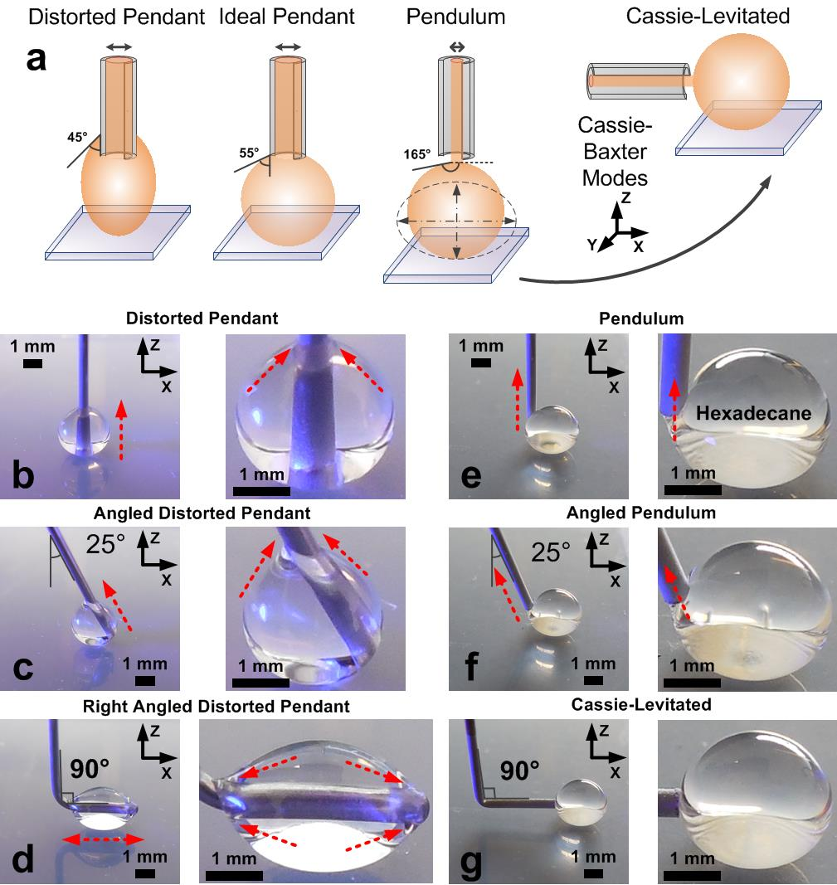
Figure 1. Evolving distortion-free probe droplets. a) The evolved droplet profiles range from the original distorted pendant model, to the less adhesive ideal pendant model, and then to the superamphiphobic pendulum model, before finally achieving the Cassie-levitated model. b) Axial shift of the original distorted pendant model, giving rise to the c) angled, and d) right-angled designs. However, these were unable to isolate the droplet profile distortions that were pinned by the wettable nature of the needle. e) The evolution of the vertical pendulum model into the f) angled and g) Cassie-levitated model. The Cassie-levitated model is almost completely interaction-free, highlighted by the lack of X- and Z- axial distortions.

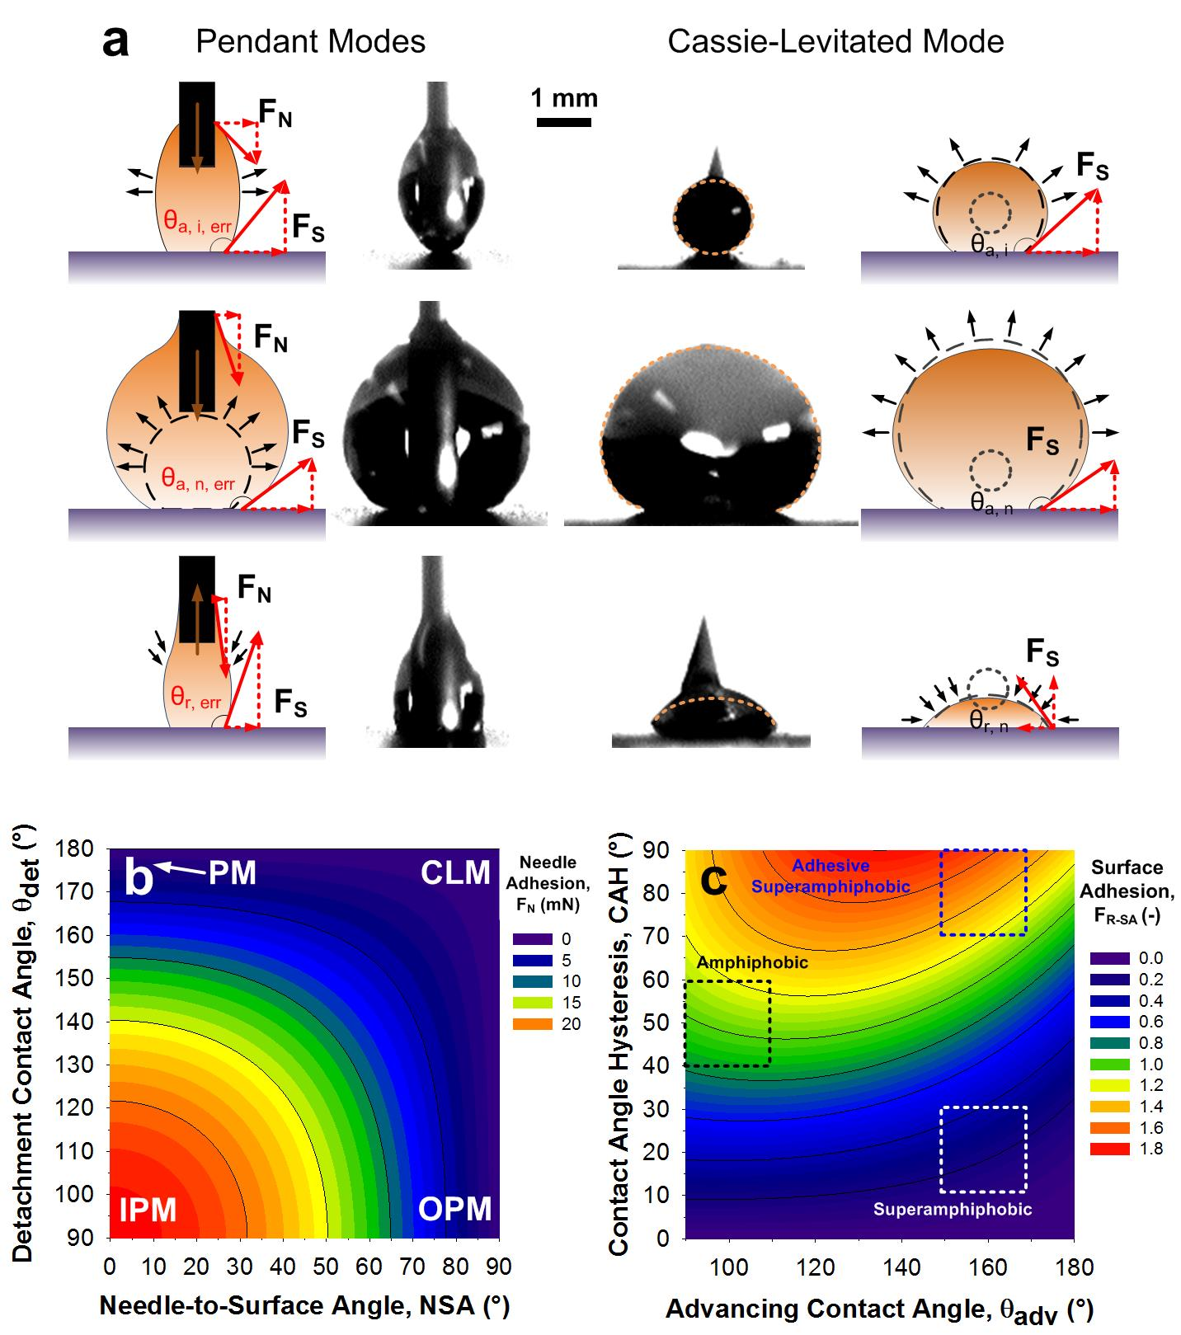
Figure 2. Contact Angle Hysteresis as Droplet Model Assessment. a) The unevolved (pendant) and completely evolved (Cassie-Levitating) models are compared side-on with an adhesive superamphiphobic substrate through the CAH test. Droplet distortions are the largest with the smallest droplet profiles, found at the start- and the end- of the CAH test. Corresponding force vectors are inserted for reference. b) The adhesion needle force profiles corresponding to the various droplet models tested in this work. c) The adhesion substrate force profiles corresponding to the surfaces tested in this work.

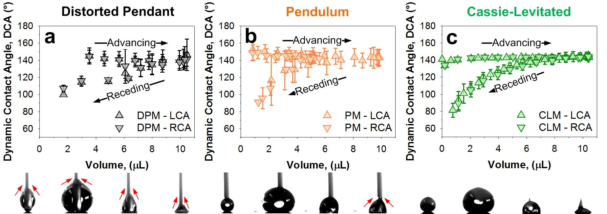
Figure 3. Contact Angle Hysteresis of Adhesive Superamphiphobic Surfaces under the Young-Laplace Model. Use of the a) distorted pendant model, b) pendulum model, c) Cassie-levitated Model. Insets are included below of optical images that are representative of the optical droplet profile during analysis.

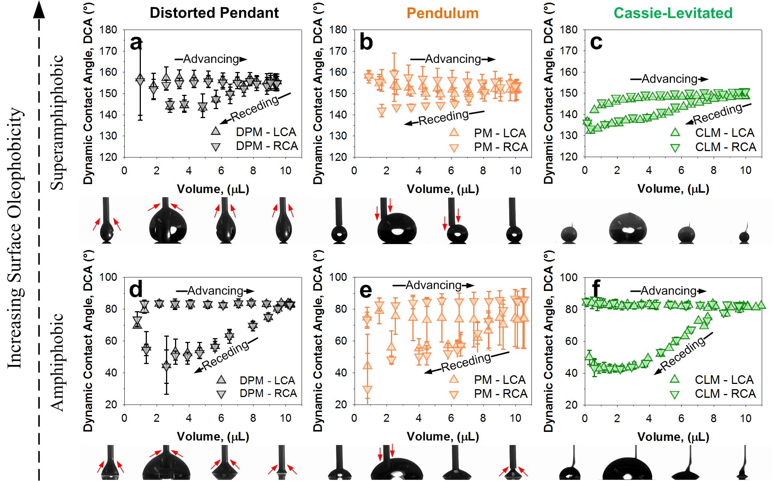
Figure 4. Contact Angle Hysteresis of Alternative Surfaces under the Young-Laplace Model. Use of the a) distorted pendant model, b) pendulum model, c) Cassie-levitated model with superamphiphobic substrates. Use of the d) distorted pendant model, e) pendulum model, f) Cassie-levitated model with amphiphobic substrates. Insets are included below of optical images that are representative of the optical droplet profile during analysis.

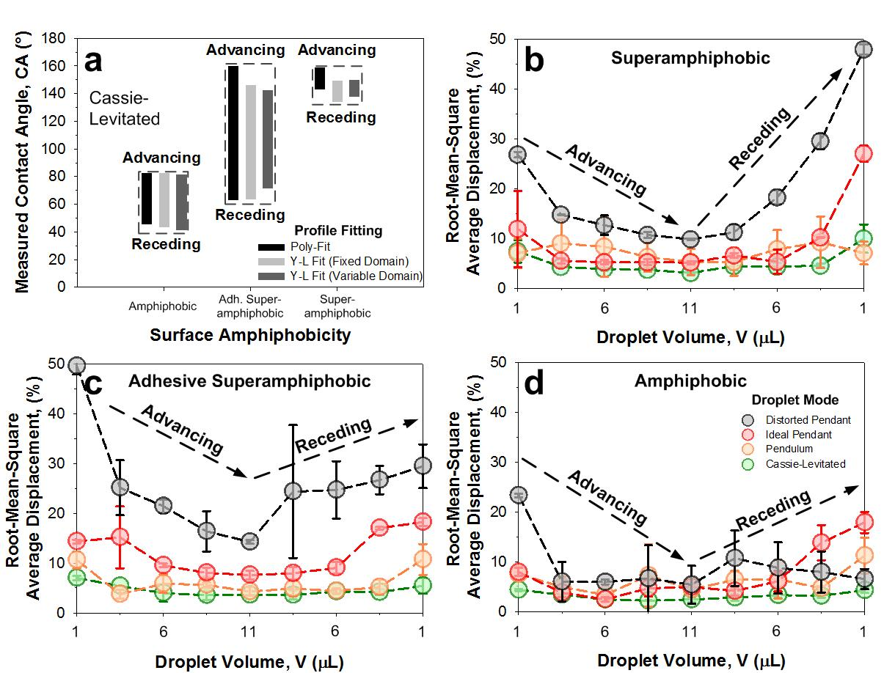
Figure 5. Experimental vs. Theoretical Profile Fitting. a) ACA, RCA and CAH fitting by the Young-Laplace model with the Cassie-levitated model against amphiphobic, adhesive superamphiphobic and superamphiphobic substrates. Machine vision-learning algorithm processed optical droplet profile to Bashforth-Adams theoretical profile fitting, with b) superamphiphobic, c) adhesive superamphiphobic and d) amphiphobic substrates.

Table 1. Adhesive Superhydrophobic Surfaces and their reported CAH (γ_{l} = 72.8 mN/m)
Morphology | Synthesis Technique | Maximum Adhesion  (mg / µN / µNmm⁻²) | Volume (μL) | CA (°) | CAH (°) | Ref.
Fractal TiO₂ nanoparticle agglomerates | Flame spray pyrolysis on paper | - | 10 | 159 | > 100 | ²⁸
Micro-pillars with ZnO nanoparticle agglomerates | Soft lithography and wet-aersol deposition of nanoparticles | 2 mg | 5 | 154 | 72 | ³¹
PS raspberry particles | Heterocoagulation of fluoro-PS nanoparticles around PS microparticles | 30 mg | CA: 5,  CAH: 25 | 146 | > 133 | ³²
PMMA micro-fibers | Electrospinning | 60 mg | Variable,  up to 90 | 130-140 | 90-120 | ³³
Micro-cilia | Magnetically aligned micro-cilia casted from PDMS-MNP | 10 mg | 10 | > 150 | 80-120 | ³⁴
Wrinkled GO microspheres | GO nano-shell with freeze-drying induced wrinkling | 10 mg, 77.8 µN | CA: 3, Ad: 4 | 153 | 120 | ³⁵

Table of Content Graphic

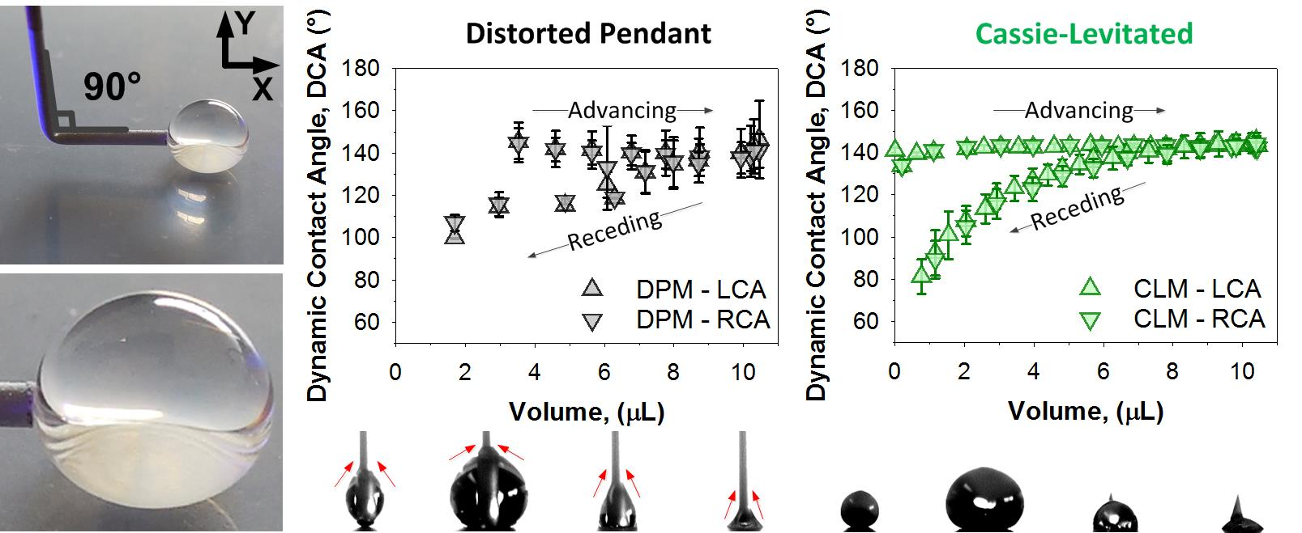

Not all surfaces were tested to their limits, but the maximum tested values are indicated.
Range of CA presented when multiple surfaces are presented.

